**DHT11 Humidity Sensor with Raspberry Pi**

DHT11 is a compact sensor which can provide temperature and humidity readings. It’s very easy to set it up with Raspberry Pi. These type of sensors are helpful in remote weather systems, soil monitors and home automation systems. In this document we are going to program it using python.

**Here are the ranges and accuracy of the DHT11:**

Humidity Range : **20-90% RH**

Humidity Accuracy : **±5% RH**

Temperature Range : **0-50 °C**

Temperature Accuracy : **±2% °C**

Operating Voltage : **3V to 5.5V**

1. **Components Required**

DHT11 Humidity sensor

10K Resistor

Raspberry Pi

Jumper wires

1. **Connecting DHT11 to Raspberry Pi**

There are two variants of the DHT11 you’re likely to come across.

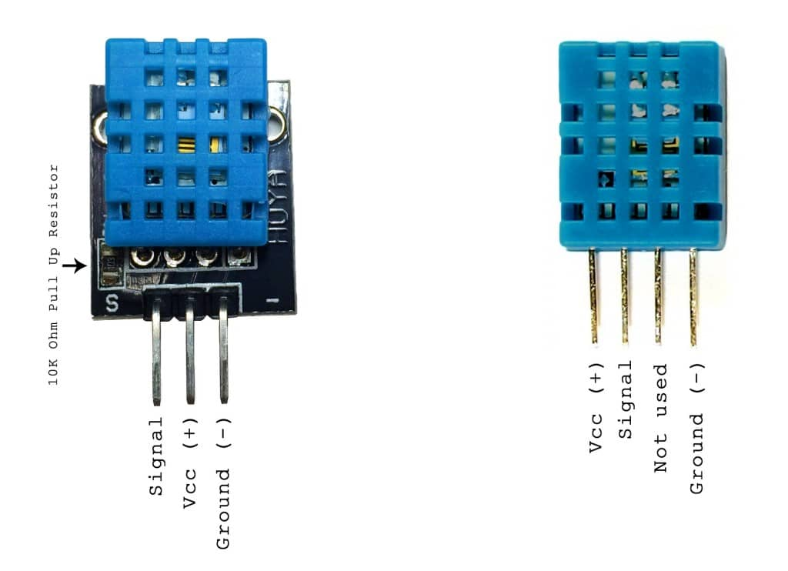

**Three pin DHt11 with SSH output:**

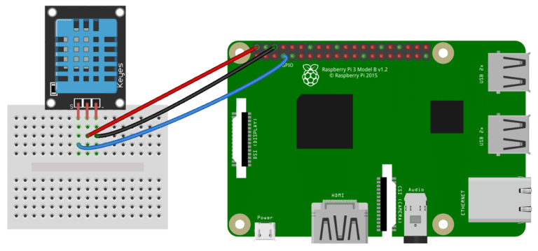

**Four pin DHT11 with SSH output:**

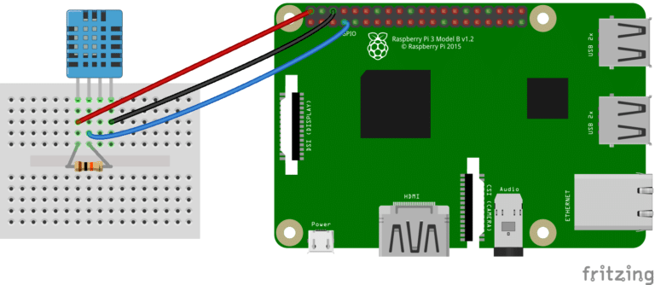

1. **Programming the DHT11 using Python**

We’ll be using the Adafruit DHT11 Python library. To install the Adafruit DHT11 library:

Enter this at the command prompt to download the library:

*git clone https://github.com/adafruit/Adafruit_Python_DHT.git*

Change directories with

*cd Adafruit_Python_DHT*

Now enter this:

*sudo apt-get install build-essential python-dev*

Then install the library with:

*sudo python setup.py install*

**Code:**

#!/usr/bin/python

import sys

import Adafruit_DHT

while True:

humidity, temperature = Adafruit_DHT.read_retry(11, 4)

print 'Temp: {0:0.1f} C Humidity: {1:0.1f} %'.format(temperature, humidity)

written by : Ashish Kumar (ashishmarch12@gmail.com)